Kaiserstand Bracket
Version 3.0

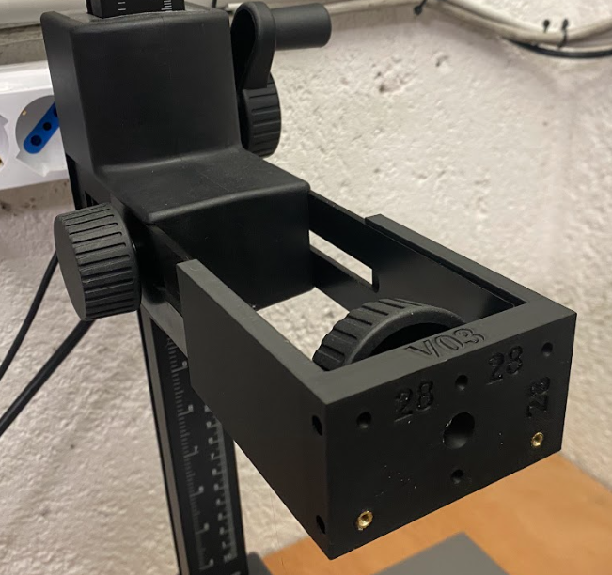

Project Goals
Create an easy to install and easy to remove bracket for Kaiser Stand

Drawings
Back size: 76x44 mm
There is an hole in the center to avoid interference with the photo mount screw.
Mounting threads are created using M3 heat set inserts
There are 6 mounting holes, 28 mm spaced.
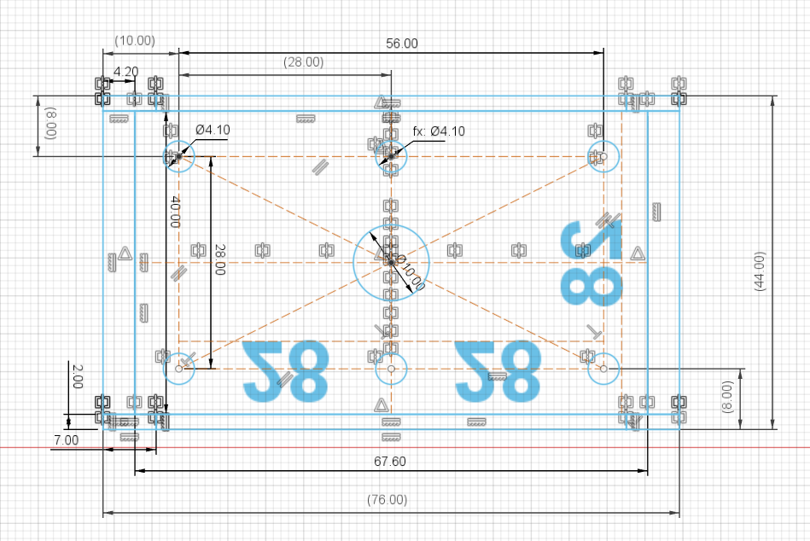

Side view
Basic dimensions: 44 x 90 mm
There are 2 mounting threads 28 mm spaced in the center.
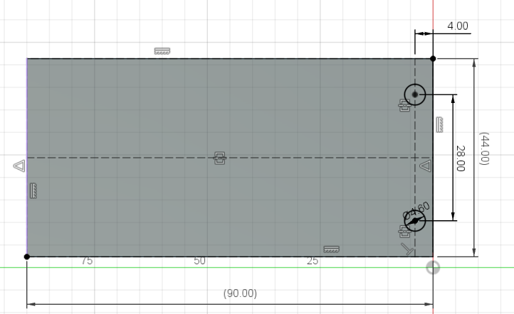

3D Rendering

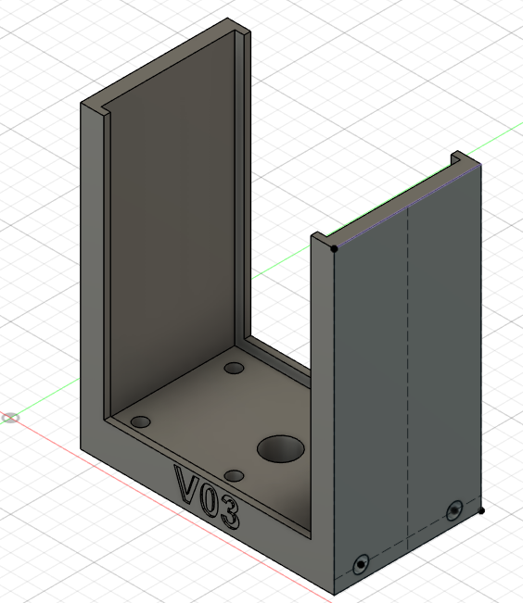

3D Printer layout
PLA Printing Time: 1h 11m
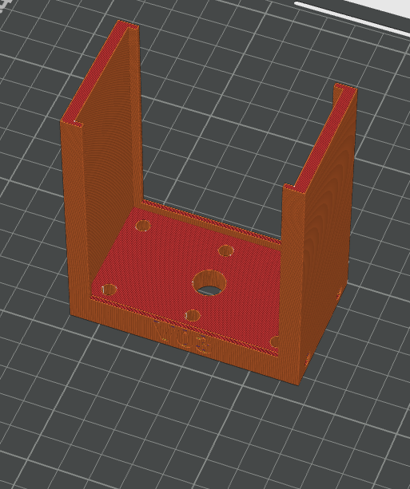

Final result
This is the final result. Not all heat inserts are in place.
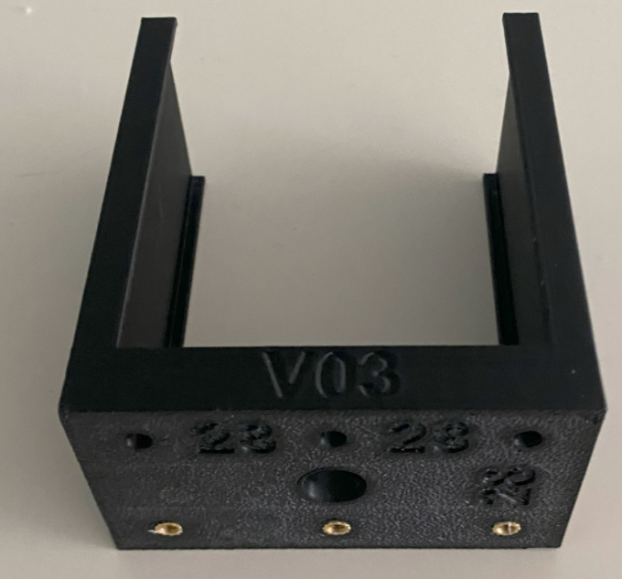 | 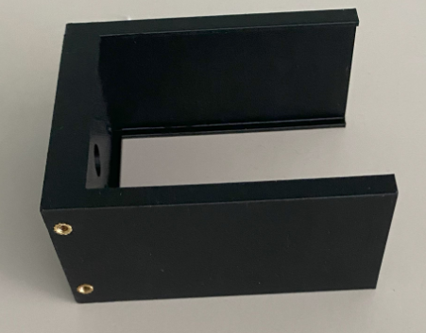

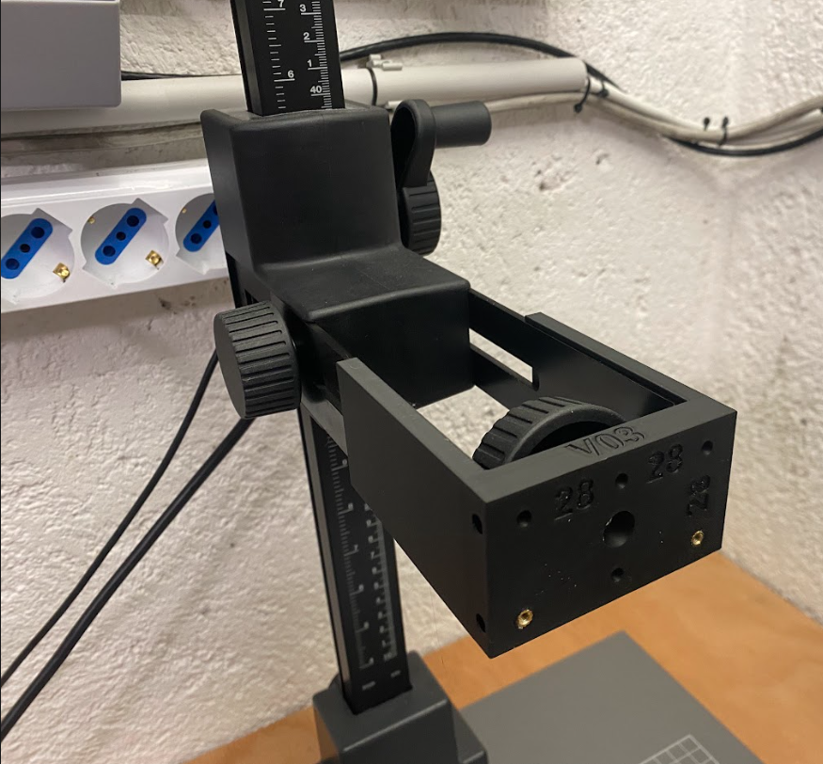

For the next Iteration
No request.

Reference

M3 Heat set insert
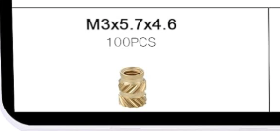
https://amzn.eu/d/2jmdR2e
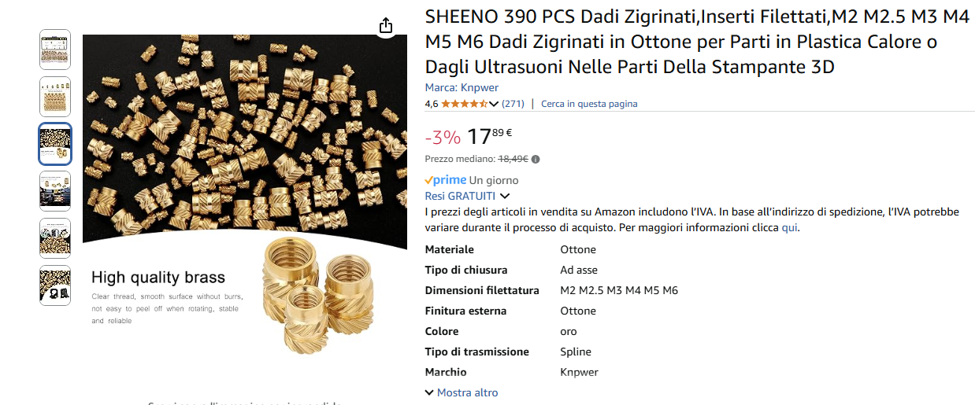

Kaiserstand
My model is RS2 XA

